
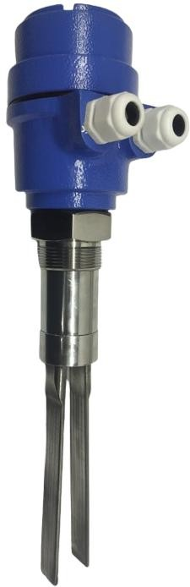
SOLID VIBRATING FORK is specially designed for detecting maximum and minimum level in silo’s filled with free-flowing solids, food grains, granules, powder s e t c . SOLIDFORK can be used for detecting the level of material having overall size less than 30 mm. Variation of electrical parameters of the service material such as conductivity and dielectric constant do not affect its operation. It can be used successfully for level detection of
lumps, powders and granules of plastic, silica, sand, cement, chalk, pulverized coal, PET, Food grains, minerals, animal feed, Sugar & wood chips etc.

Operating Principle:
The Tuning Fork is kept vibrating at its mechanical resonant frequency by Piezo elements. When the service material covers the tines, it resists its movement and so the vibrations are damped. The stopped vibrations
is sensed electrically and the signal is processed to signal an alarm and or control a relay. The relay contacts can be used to control the feed motor or evacuation valve etc.
Salient Features:
- Compact size with integral electronics
- No calibration required, so plug and play device.
- No moving parts so no wear and tear
- Universal Power supply for AC I DC operation
- Medium size fork design @ 200 mm for minimum insertion in small silos.
- Available in 1½ inchand above screwed mounting standards

- IP 68 ingress protection
- Field Selectable fail-safe mode
- LED indicators for status, alarm and normal operation
- Selectable Density setting and switching delay

Model: VFLS-200S
Make: Levtron Instruments Pvt Ltd. Pune

Technical Specifications Mechanical:
Housing: Cast Aluminium IP 68
Type: Integral with probe with Electronics
Insertion Length: 200 MM Standard (Additional lengths on Request)
Mounting: 1½” BSP standard SS 304
Pipeextension M.O.C.: SS304 / SS316 as per requirement
Tuning Fork: SS316
Cable Entry: PG 13.5/PG 16
Cable Gland: Single compression PG13.5/PG 16
Electronics:

Power supply: 24 V DC OR 110 / 230 V AC SPECIFY.
Power consumption: 3 VA Max. Out Put: DPDT Relay
Relay output: Potential. free change over contacts rated at 6A 230 V AC 5O Hz
Resonant frequency of fork: 135 Hz approx. for 200 mm fork
Switching delay: Adjustable up to 20 sec. for fork covered or uncovered condition
Failsafe condition: High / Low field selectable.
Sensitivity:For Medium and High density material
Indication: LEDs, Yellow for Normal, and Red for Alarm.

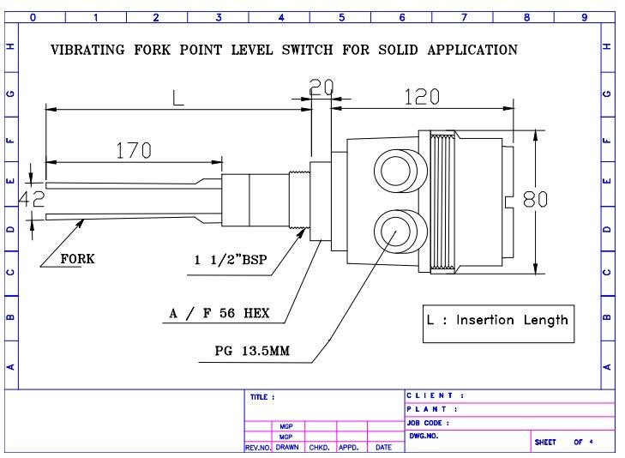
INFORMATION REQUIRED Before Purchase

- Process Parameters: Process Connection, Process Temperature, Vessel pressure if any.
- Application media characteristics: Density, Viscosity, Sp. Gr.
- Supply Voltage, Probe length, Mounting etc.

Mechanical Drawing:

Manufactured By:

Levtron Instruments Pvt Ltd.
Office No 2, 1st floor, plot no 6, Pandhari Industrial estate, Shivane. Pune 411023, Contact: 09579430012 / 9730042725 E-mail: sales@levtron.in, Website : www.Levtron.in

